**MUHAMMAD MUAAZ SHOAIB  
FA20-BCS-074  
CC MID LAB  
25-OCT-2023**

**Q1: Briefly describe the regex library of C#.**

The regex library of C# is a powerful tool for working with regular expressions. It provides a set of classes and methods that allow you to match, search, and replace text based on regular expression patterns.

The most important class in the regex library is the Regex class. This class represents a regular expression and provides a variety of methods for working with it. For example, you can use the **Match()** method to find a match for the regular expression in a given string, and the Replace() method to replace all matches for the regular expression with a new string.

The regex library also includes several other classes and methods that can be useful for working with regular expressions. For example, the **MatchCollection()** class represents a collection of matches for a regular expression, and the Group class represents a group of characters within a match.

**Key Classes in C# Regex Library:**

1. **Regex:** The `Regex` class is the primary class in the library. It represents a compiled regular expression pattern and provides methods for pattern matching and replacement.
2. **Match:** The `Match` class represents a single match of a regular expression pattern in an input string. It provides information about the matched text and its position.
3. **MatchCollection:** This class represents a collection of `Match` objects. It is returned by methods like `Regex.Matches()` when you want to find all matches in an input string.

**Basic Operations:**

1. **Pattern Matching (Regex.Match):** You can use `Regex.Match()` to find the first occurrence of a regular expression pattern in an input string. It returns a `Match` object containing information about the first match.
2. **Pattern Matching (Regex.Matches**): The `Regex.Matches()` method finds all occurrences of a pattern in an input string and returns a `MatchCollection` containing all the matches.
3. **Pattern Replacement (Regex.Replace):** You can use `Regex.Replace()` to replace all occurrences of a pattern in an input string with a specified replacement string.

Common Regex Elements:

1. **Literals:** Characters that match themselves, e.g., "abc" matches the string "abc."
2. **Character Classes:** Square brackets define character classes, like `[A-Za-z]` to

match any uppercase or lowercase letter.

1. **Quantifiers:** Specify how many times a character or group should appear. For

example, `*` matches zero or more times, and `+` matches one or more times.

1. **Anchors:** `^` matches the start of a line, and `$` matches the end.
2. **Escape Sequences**: Backslashes `\` are used to escape special characters. For

example, `\.` matches a literal period, and `\d` matches a digit.

Here is an example of how to use the regex library to match and replace text:

C#

// Create a regular expression object

Regex regex = new Regex(@"\d+");

// Match the regular expression in the input string

Match match = regex.Match("This string contains 123 numbers");

// If there is a match, replace it with the string "numbers"

if (match.Success)

{

string output = match.Result.Replace("123 numbers", "numbers");

Console.WriteLine(output); // This string contains numbers

}

The regex library is a very powerful tool for working with text, and it can be used to solve a wide variety of problems.

Here are some of the benefits of using the regex library of C#:

* It is very efficient and can be used to process large amounts of text quickly.
* It is very flexible and can be used to create complex regular expression patterns.
* It is well-documented and there are many resources available to help you learn how to use it.

If you need to work with text in your C# applications, I highly recommend using the regex library.

**Q2: Make recursive descent or LL1 parser for the following grammar:**

**S -> E$**

**E -> T E'**

**E' -> + T E' | ε**

**T -> F T'**

**T' -> * F T' | ε**

**F -> ( E ) | id**

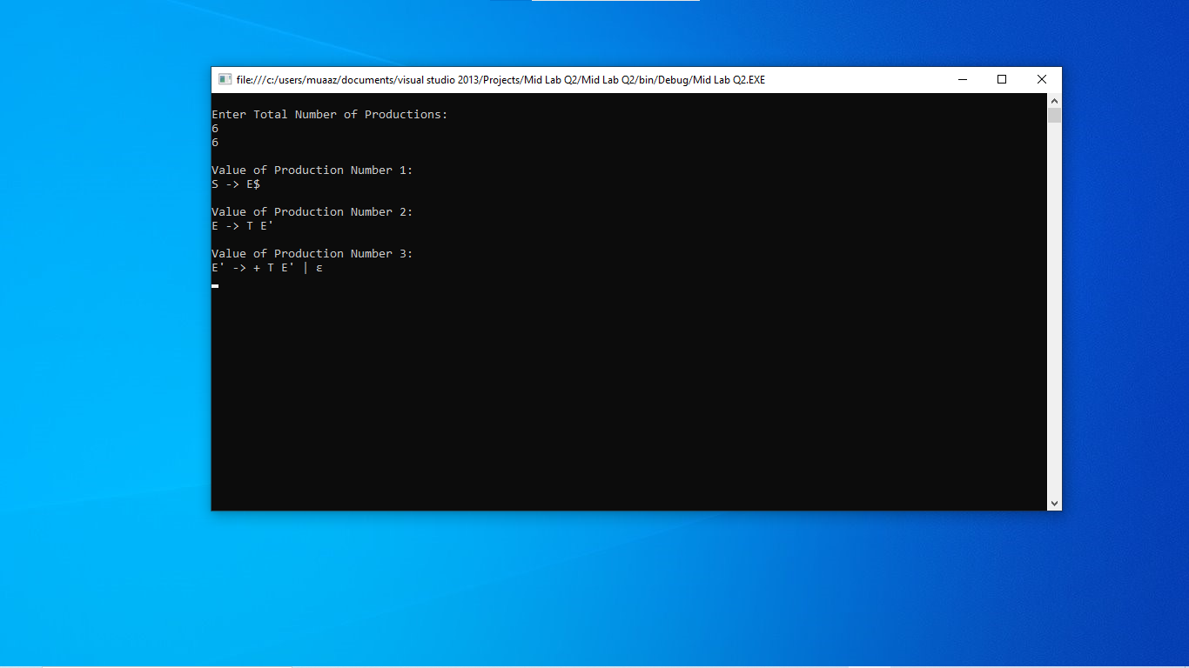

using System;

using System.Collections.Generic;

using System.Linq;

using System.Text;

using System.Threading.Tasks;

namespace Mid_Lab_Q2

{

class Program

{

static int limit, x = 0;

static char[,] production = new char[10, 10];

static char[] array = new char[10];

static void Main(string[] args)

{

for (int i = 0; i < 10; i++)

{

for (int j = 0; j < 10; j++)

{

//To signify empty space.

production[i, j] = '-';

}

}

int count = 0;

char option, ch;

Console.WriteLine("\nEnter Total Number of Productions:\t");

limit = Convert.ToInt32(Console.ReadLine());

Console.WriteLine(limit);

for (count = 0; count < limit; count++)

{

Console.WriteLine("\nValue of Production Number {0}:\t", count + 1);

String temp = Console.ReadLine();

for (int i = 0; i < temp.Length; i++)

{

production[count, i] = temp[i];

}

}

// Keep asking the user for non-terminal for which follow_set is needed.

do

{

x = 0;

Console.WriteLine("\nEnter production Value to Find Follow:\t");

ch = Console.ReadKey().KeyChar;

find_follow(ch);

Console.WriteLine("\nFollow Value of {0}:\t", ch);

for (count = 0; count < x; count++)

{

Console.Write(array[count]);

}

Console.Write("}\n");

Console.Write("To Continue, Press Y:\t");

option = ch = Console.ReadKey().KeyChar;

} while (option == 'y' || option == 'Y');

for (int i = 0; i < 10; i++)

{

for (int j = 0; j < 10; j++)

{

Console.Write(production[i, j]);

}

Console.Write("\n");

}

Console.ReadKey();

}

static void find_follow(char ch)

{

int i = 0, j;

for (int k = 0; k < 10; k++)

{

}

int length = 10;

if (Convert.ToChar(production[0, 0]).Equals(ch))

{

array_manipulation('$');

}

for (i = 0; i < limit; i++)

{

for (j = 2; j < length; j++)

{

if (Convert.ToChar(production[i, j]).Equals(ch))

{

if (Convert.ToChar(production[i, j + 1]).Equals('\0'))

{

find_first(Convert.ToChar(production[i, j + 1]));

}

if (Convert.ToChar(production[i, j +

1]).Equals('\0') && ch.Equals(Convert.ToChar(production[i, 0])))

{

find_follow(Convert.ToChar(production[i, 0]));

}

}

}

}

}

static void find_first(char ch)

{

int i = 0, k;

//Check for uppercase letter.

int val = System.Convert.ToInt32(ch);

if (!(val >= 97 && val <= 122))

{

array_manipulation(ch);

}

for (k = 0; k < limit; k++)

{

if (production[k, 0].Equals(ch))

{

if (production[k, 2].Equals('$'))

{

find_follow(Convert.ToChar(production[i,

0]));

}

//Check for lowercase.

else if (Convert.ToInt32((production[k, 2])) >=

97 && Convert.ToInt32((production[k, 2])) <= 122)

{

array_manipulation(Convert.ToChar(production[k, 2]));

}

else

{

find_first(Convert.ToChar(production[k, 2]));

}

}

}

}

static void array_manipulation(char ch)

{

int count;

for (count = 0; count <= x; count++)

{

if (array[count].Equals(ch))

{

return;

}

}

array[x++] = ch;

}

}

}

**Q3: Make a Password generator according to the following rules:**

**(a) At least one uppercase alphabet**

**(b) At least 4 numbers**

**(c) At least 2 special characters**

**(d) Must contain initials of first and last name**

**(e) maximum length of 16**

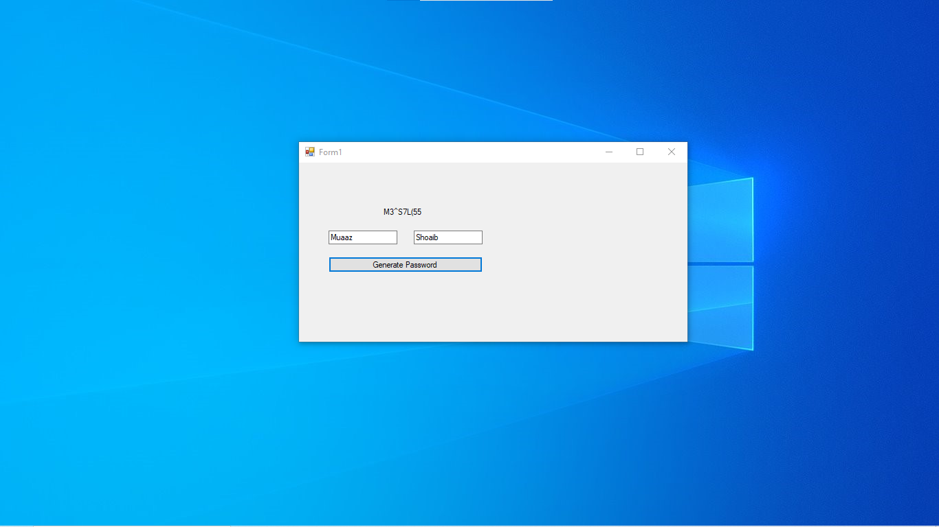

using System;

using System.Collections.Generic;

using System.ComponentModel;

using System.Data;

using System.Drawing;

using System.Linq;

using System.Text;

using System.Threading.Tasks;

using System.Windows.Forms;

using System.Text;

using System.Text.RegularExpressions;

namespace Mid_Lab_Q3

{

public partial class Form1 : Form

{

public Form1()

{

InitializeComponent();

}

private void Form1_Load(object sender, EventArgs e)

{

}

private void button1_Click(object sender, EventArgs e)

{

string firstName = "Muaaz";

string lastName = "Shoaib";

if (firstName.Length < 1 || lastName.Length < 1)

{

MessageBox.Show("Please enter your first and last name.");

return;

}

// Create a StringBuilder to build the password

StringBuilder password = new StringBuilder();

// Add initials of first and last name

password.Append(firstName[0]);

password.Append(lastName[0]);

// Generate random uppercase alphabet

Random random = new Random();

password.Append((char)random.Next('A', 'Z' + 1));

// Generate 4 random numbers

for (int i = 0; i < 4; i++)

{

password.Append((char)random.Next('0', '9' + 1));

}

// Generate 2 special characters

string specialCharacters = "!@#$%^&*()_-+=<>?";

for (int i = 0; i < 2; i++)

{

password.Append(specialCharacters[random.Next(specialCharacters.Length)]);

}

// Shuffle the password characters for better security

password = ShuffleString(password);

// Limit the password to a maximum length of 16

if (password.Length > 16)

{

password.Length = 16;

}

// Display the generated password

label1.Text = password.ToString();

}

private StringBuilder ShuffleString(StringBuilder str)

{

Random random = new Random();

int n = str.Length;

while (n > 1)

{

n--;

int k = random.Next(n + 1);

char value = str[k];

str[k] = str[n];

str[n] = value;

}

return str;

}

}

}